**18th South East Essex Boys’ Brigade**

**Years R to 3 Thursdays at 5:30-7:00**

**Years 4 to 6 Fridays at 6:15-7:45**

**Years 7 to 11 Fridays at 7:45-9:15/30**

**£2 per week at Rayleigh Baptist Church**

**For fun, games and new challenges**

**New members are always welcome.**

Find out more by calling 01268 745730

or emailing [reception@rayleighbaptist.org.uk](mailto:reception@rayleighbaptist.org.uk)

or just come along. N0 WAITING LISTS

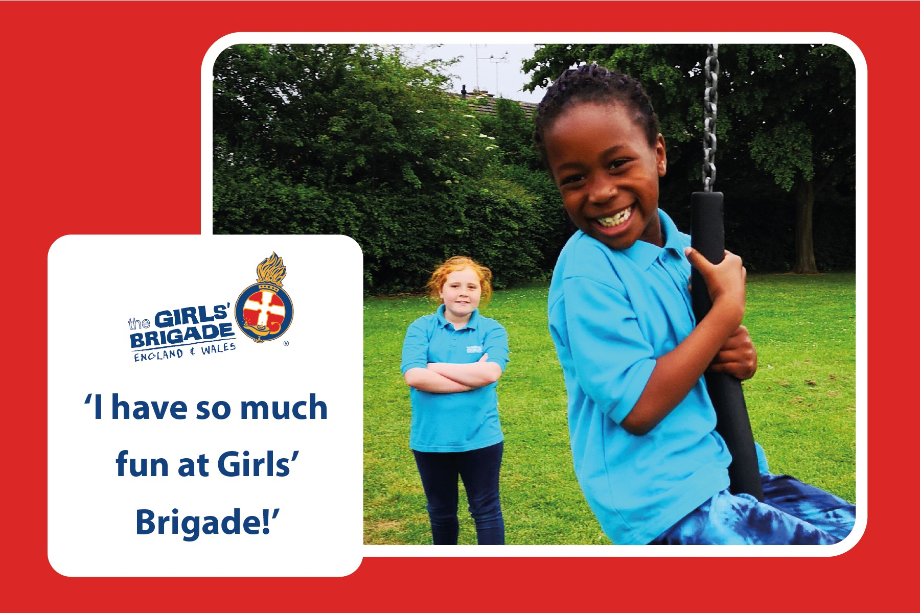

3rd Rayleigh Girls’ Brigade

Rayleigh Baptist Church Wednesdays at 5:30-7:00 (£2 per week)

Exciting activities for girls aged 4-14

New members are always welcome.