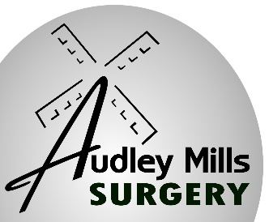

**AUDLEY MILLS SURGERY**

**57 Eastwood Road, Rayleigh, Essex. SS6 7JF**

**\*\* COMPETITION \*\***

* **Are you 11 or under?**
* **Do you like drawing?**

**Draw a picture to go on the front of our practice brochure. This brochure will be seen by all our patients (20,000) as well as being available online.**

**Draw a picture which best shows our doctors surgery. This will be judged by the partners and the winner will receive a prize of a £50 gift voucher.**

**Closing date is 1st September 2024**

**Please drop all entries to: Audley Mills Surgery, 57 Eastwood Road, Rayleigh for the attention of the Practice Manager – Remember to put your name, age and phone number on the back.**

**Good luck!**