

Mrs Fagence’s disney curriculum

Enjoy!

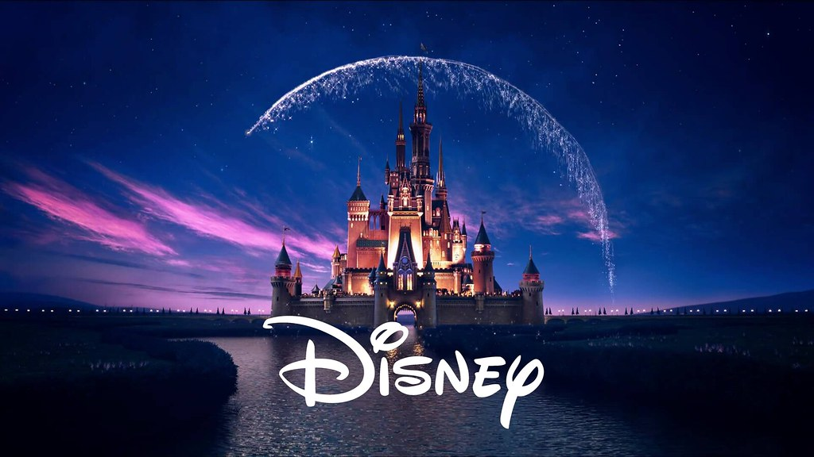

|  |  |  |  |  |  |
| --- | --- | --- | --- | --- | --- |
| Week | 1  Aladdin | 2  Lion King | 3  Beauty and the Beast | 4  The Little Mermaid | 5  Dumbo |
| Geography | What country is the movie set in?  What is the climate like?  What language is spoken?  Where did the tale originally come from?  What is the terrain like? How does this terrain differ from yours? Name all the different terrains in the world and label a world map on where they can be found. | What continent is the movie set in? What oceans/seas are surrounding this continent?  Draw the continent outline and research the countries within. Add these to your map. | Which country/continent is this movie set in?  Belle lives in a small town, what services are available in this town? How are these services different to what you have in your town? How are they similar? | Ariel lives in the ocean however is fascinated with land and eventually brings both communities together. Draw a world map of all the oceans/seas. Plot a route Prince Eric to travel along. Choose a location for Atlantica (Ariel’s home). Why have you chosen these locations? | Dumbo is set in USA and travels through many states. Research a selection of these states and create a fact file to include climate, population, religion, exports/imports, leisure. |
| Science | **Space**  Aladdin spends most of his time staring into the night sky or towards the palace. Although he doesn’t always see the same stars, as they seem to move. Do the stars move? Research planets and how they move within the solar system. | **Life cycles and Food chains**  Choose an animal from the movie and draw a life cycle poster.  Design and draw a comic strip showing the food chain for the same animal. | **Plants**  The rose is an essential part to the movie. What are the different parts to the rose? Can you label each one? Have a go at drawing one and label each part. How do they reproduce?  What is needed to stay alive? | **Materials and Properties**  Materials have different properties and purposes. What would the best material be for Eric’s ship? Experiment using different materials. | **Forces**  What forces would be acting upon the magic carpet? What would the most effective shape be for the magic carpet? Why? Experiment using different shapes. Dumbo uses a magic feather to soar through the sky. |
| English | **Setting description**  Choose from the following settings: Market, Cave of wonders, Sultan’s Palace. | **Narrative with dialogue** Write a side story linked to Timone and Pumba. | **Instructions**  How to grow a rose. | **Persuasive**  Should Ariel be allowed to live on the land? | **Discussion text**  Should animals be kept in a circus? |
| Languages/Food Tech/D&T/Art | Draw the palace during sunset. | Design and make puppets to retell the story. | Create a traditional recipe from the country and learn the names of the ingredients in that language. | Create a collage of an underwater scene from the movie. | Design and create a circus tent. Consider most effective materials and shape. |