**Create a Lockdown Family Handprints Salt Dough Plaque**

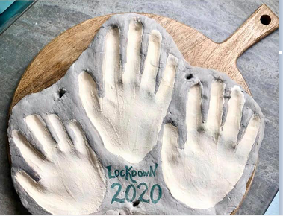

**What You Need:**

500g plain flour

250g salt

250ml water

**How To Do It:**

* Mix ingredients into a dough
* Roll out and press handprints into the dough (if you want to hang the plaque when it is finished add the holes now)
* Bake in the oven on a low temperature for 3-4 hours
* Paint and then varnish to seal