Class spellings (which we have been focusing on already this week, these are just for you to remember )

competition

apologised

scissors

helped

neighbour

genuine

audience

February

proudly

interrupted

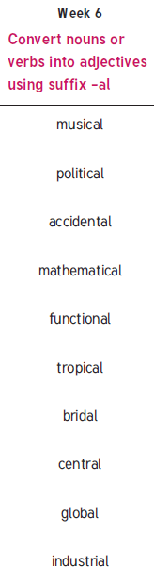

New spellings which you need to learn for next Friday 😊