Class spellings (which we have been focusing on already this week, these are just for you to remember )

piece

peace

knot

not

passed

past

beautiful

dazzling

tranquil

quiet

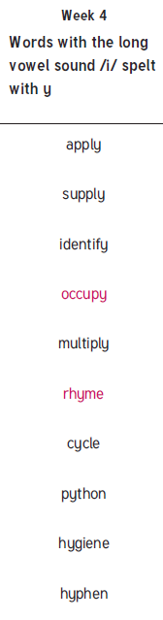

New spellings which you need to learn for next Friday 😊