***Home Learning***

*For your home learning over half term, you have 2 tasks.*

*Task 1:* For World Book Day this year, we are inviting children to decorate a potato as a character from a book or create a scene from a book using potatoes. The more creative the better!

These are due in Friday 7th March and will be judged by the Wyburns’ team and there are prizes to be won!

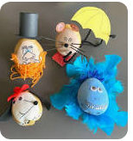 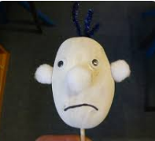 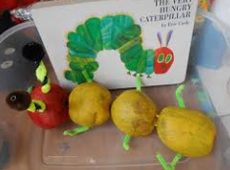

*Task 2 is to find somewhere really unique to read and get someone to take a photo of you! Please bring in your photos for a WBD reading competition. You can either send them in on Google Classroom or bring them in. You can enter as many times as you like!*

*Happy reading!*

*Team Wyburns*