Class spellings (which we have been focusing on already this week, these are just for you to remember )

ought

bought

rough

sensible

official

partial

Christmas

festive

season

weather

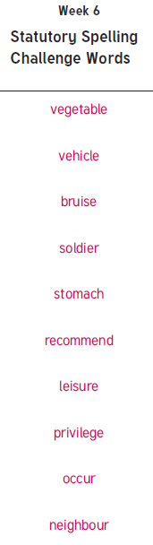New spellings which you need to learn for next Friday 😊