Class spellings (which we have been focusing on already this week, these are just for you to remember )

vision

facial

influence

diversion

magnificent

debt

cautiously

residential

antidote

coincidence

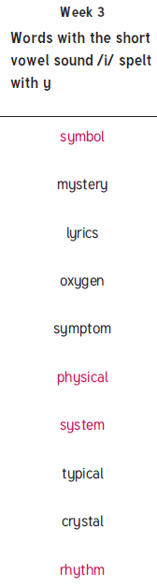New spellings which you need to learn for next Friday 😊