***Home learning***

*For your home learning over half term, you have 2 tasks.*

*Task 1: Create a book in a box! You can use a shoebox/amazon box/cereal box or create a story box out of a piece of paper.*

*Have a look at the examples:*

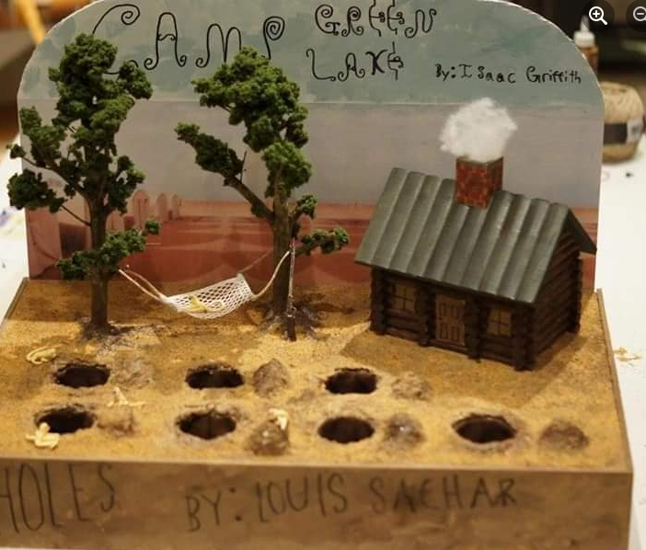 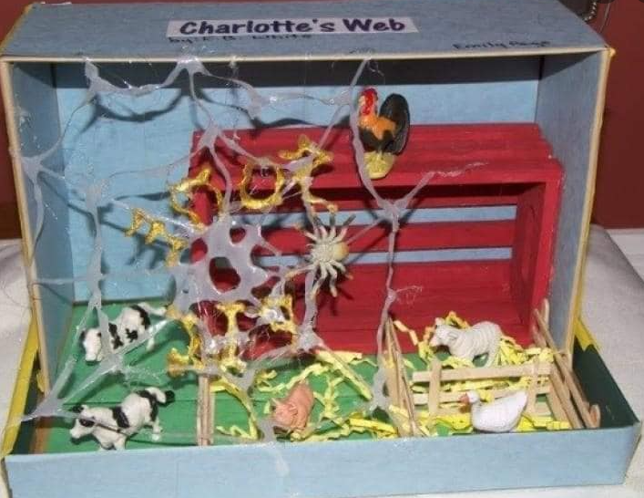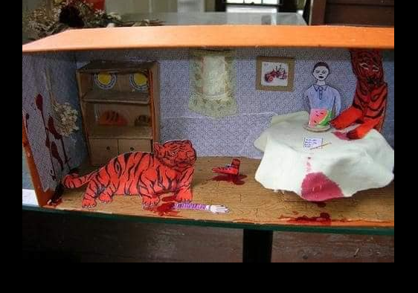

*Task 2 is to find somewhere really unique to read and get someone to take a photo of you! Please bring in your photos for a WBD reading competition. You can either send them in on google classroom or bring them in. You can enter as many times as you like!*

*Happy reading!*

