Class spellings (which we have been focusing on already this week, these are just for you to remember )

mini-beast

minimal

microscope

microchip

microphone

minicar

minimum

minicomputer

coughing

dictionary

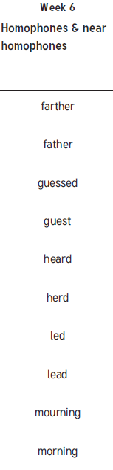New spellings which you need to learn for next Friday 😊