Class spellings (which we have been focusing on already this week, these are just for you to remember )

honest

rhino

yolk

numb

thumb

wrist

gnaw

whirl

half

calf

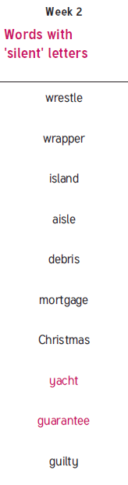New spellings which you need to learn for next Friday 😊