Class spellings (which we have been focusing on already this week, these are just for you to remember )

referee

sandwich

sew

terrible

social

so

sugar-free

reference

reliable

suffering

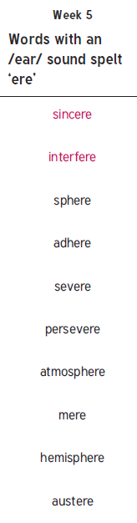

New spellings which you need to learn for next Friday 😊