Class spellings (which we have been focusing on already this week, these are just for you to remember )

minibus

microchip

microscope

microphone

miniscule

tolerant

special

thistle

absent

accent

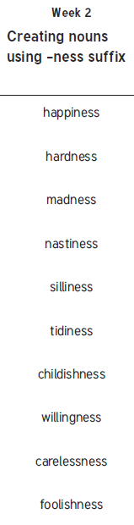New spellings which you need to learn for next Friday 😊