Class spellings (which we have been focusing on already this week, these are just for you to remember )

rational

irrational

regularity

irregularity

irrelevant

relevant

replaceable

irreplaceable

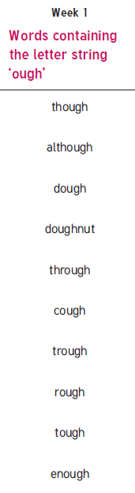responsible

irresponsible

New spellings which you need to learn for next Friday 😊