Class spellings (which we have been focusing on already this week, these are just for you to remember )

twenty-two

mid-week

co-operate

cooking-oil

t-shirt

fought

gracious

hesitant

gnat

essential

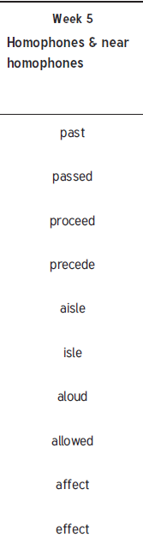

New spellings which you need to learn for next Friday 😊