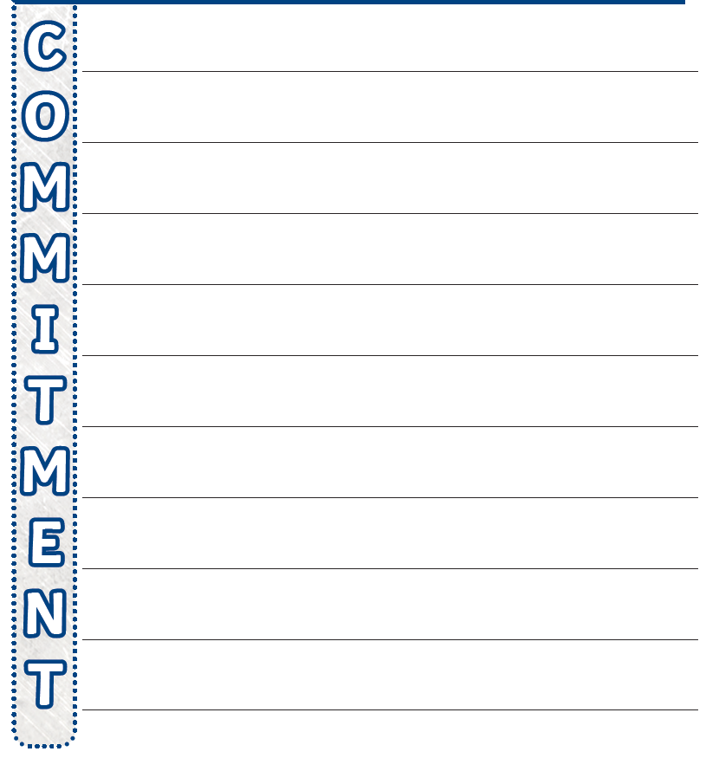This week we have looked at commitment , we have explored the idea of commitment by thinking of examples in our own lives e.g. sport, dancing, clubs (brownies/cubs), family, friends, schoolwork. We are now going to link our ideas to create an acrostic poem. Think about what commitment means to you and complete below 😊