Class spellings (which we have been focusing on already this week, these are just for you to remember )

future

courage

gracious

interval

stomach

medicine

potential

audible

precision

attendance

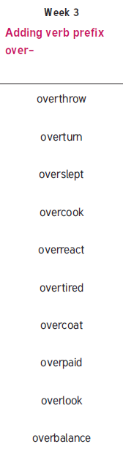New spellings which you need to learn for next Friday 😊