Class spellings (which we have been focusing on already this week, these are just for you to remember )

goose
women
woman
geese
die
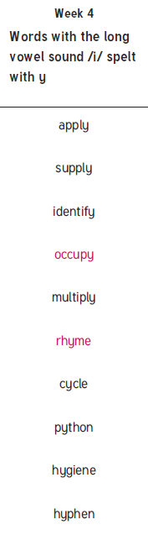
dice
accent
aloud
tooth
teeth

New spellings which you need to learn for next Friday

