Class spellings (which we have been focusing on already this week, these are just for you to remember )

kneel

misplaced

spacious

chaos

residential

importance

cousin

radiant

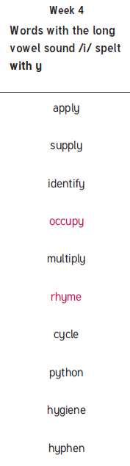squashed

bruised

New spellings which you need to learn for next Friday 😊