Class spellings (which we have been focusing on already this week, these are just for you to remember )

rhyme

interrupt

appreciate

temperature

ancient

environment

muscle

occupy

significant

according

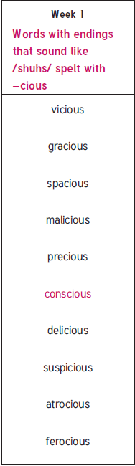

New spellings which you need to learn for next Friday 😊