Class spellings (which we have been focusing on already this week, these are just for you to remember )

bough

cough

brought

dough

ought

rough

tough

fought

brought

thought

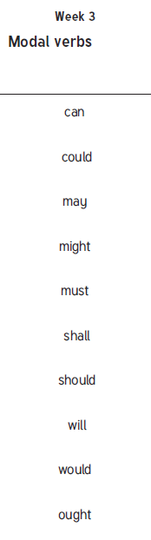

New spellings which you need to learn for next Friday 😊