Class spellings (which we have been focusing on already this week, these are just for you to remember )

rhyme

time

climb

disastrous

determined

queue

awkwardly

prime

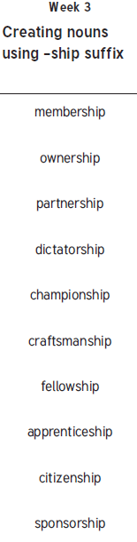dime

suggested

New spellings which you need to learn for next Friday 😊