Class spellings (which we have been focusing on already this week, these are just for you to remember )

accommodate

bruise

category

environment

vegetable

embarrass

parliament

cemetery

marvellous

nuisance

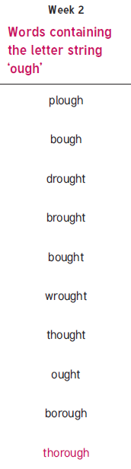

New spellings which you need to learn for next Friday 😊