Class spellings (which we have been focusing on already this week, these are just for you to remember )

simplify

medicate

apologise

populate

notify

pollinate

purify

standardise

deepen

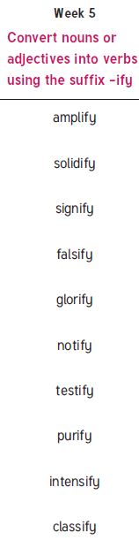darken

New spellings which you need to learn for next Friday 😊