Class spellings (which we have been focusing on already this week, these are just for you to remember )

Autumn

magnificence

sought

leisure

jogged

subscribe

flexible

sparkly

reign

knot

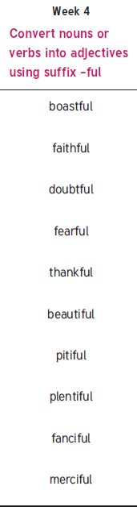New spellings which you need to learn for next Friday 😊