Class spellings (which we have been focusing on already this week, these are just for you to remember )

scent

science

scissors

descend

honest

discipline

autumn

comb

numb

climb

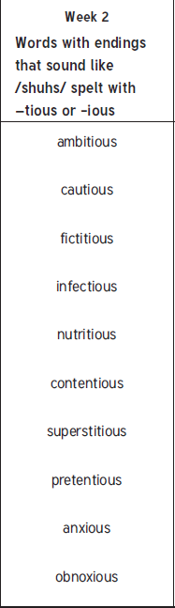New spellings which you need to learn for next Friday 😊