Class spellings (which we have been focusing on already this week, these are just for you to remember )

solve

resolve

dissolve

solution

absolve

antifreeze

autograph

antiseptic

automatic

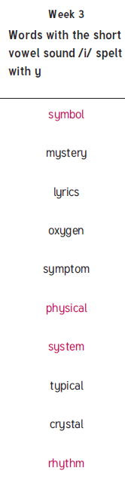antibiotic

New spellings which you need to learn for next Friday 😊