Class spellings (which we have been focusing on already this week, these are just for you to remember )

restaurant

soared

blistering

owners

customers

complained

yelling

persuaded

calm

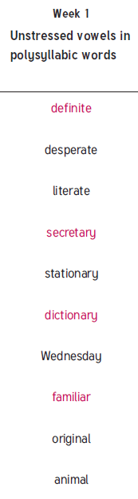environment

New spellings which you need to learn for next Friday 😊