Class spellings (which we have been focusing on already this week, these are just for you to remember )

weight

eight

neighbour

sleigh

beige

neigh

responsibility

disappointedly

veil

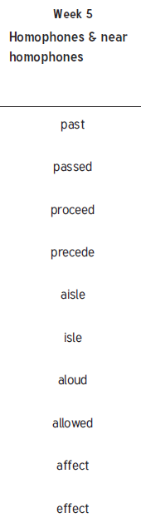reign

New spellings which you need to learn for next Friday 😊