Class spellings (which we have been focusing on already this week, these are just for you to remember )

cofounder

cohabit

codiscover

coincidence

coemploy

cofounder

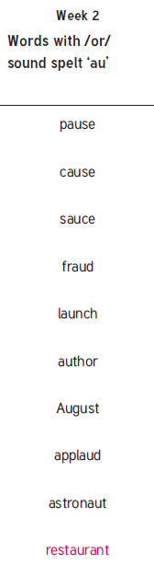coordinate

coauthor

coattend

coexist

New spellings which you need to learn for next Friday 😊