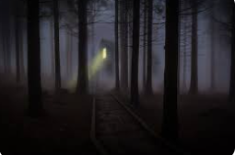
Your task is to write creatively about the picture. We have worked hard on our sentence structures. Please think carefully about punctuation and accurate use of capital letters.

You must include figurative language and fronted adverbials

