Class spellings (which we have been focusing on already this week, these are just for you to remember)

hairbrush

wheelchair

underwear

seesaw

freefall

cheerleader

spearmint

walkway

waterfall

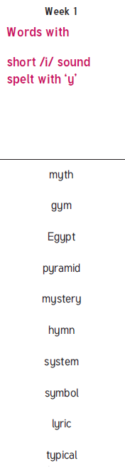tragic

New spellings which you need to learn for after Christmas 😊