Class spellings (which we have been focusing on already this week, these are just for you to remember)

can’t

I’ve

I’d

doesn’t

wouldn’t

couldn’t

won’t

confusion

occasionally

shouldn’t

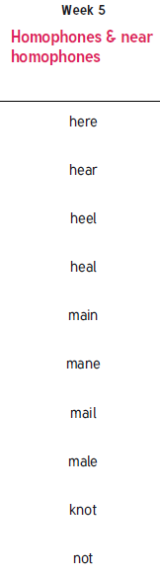New spellings which you need to learn for next Friday 😊