Class spellings (which we have been focusing on already this week, these are just for you to remember)

kindly

happily

angrily

basically

automatically

actually

gently

action

accident

vaccine

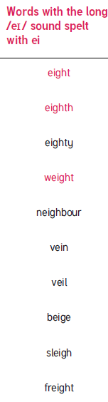

New spellings which you need to learn for next Friday 😊