Class spellings (which we have been focusing on already this week, these are just for you to remember)

hesitation

scorch

treasure

antique

information

multiplication

division

junction

action

completion

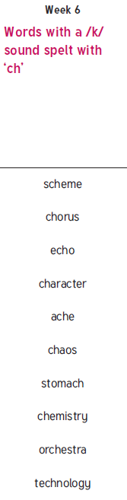

New spellings which you need to learn for next week😊