Class spellings (which we have been focusing on already this week, these are just for you to remember)

grown

malleable

heal

affect

except

heel

groan

bury

berry

brake

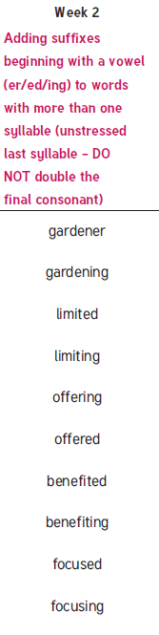

New spellings which you need to learn for next week😊