Class spellings (which we have been focusing on already this week, these are just for you to remember)

isn’t

unkind

dislike

untidy

disobey

unfair

unlucky

disagree

unfriendly

anxious

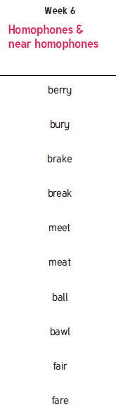 New spellings which you need to learn for next Friday 😊