Class spellings (which we have been focusing on already this week, these are just for you to remember)

pencil

fossil

soil

nail

picture

pleasure

treasure

remember

nature

flail

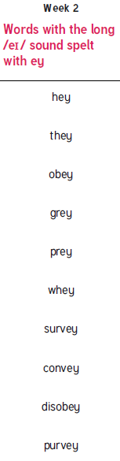New spellings which you need to learn for next Friday 😊