Class spellings (which we have been focusing on already this week, these are just for you to remember)

flawed

helped

rocked

rolled

washed

heal

heel

heart

heard

laughed

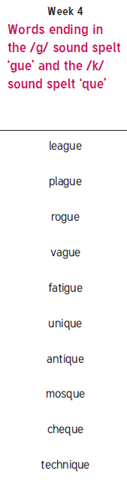New spellings which you need to learn for next week😊