Class spellings (which we have been focusing on already this week, these are just for you to remember)

scheme

chorus

chemist

Christmas

echo

character

immaculate

hideous

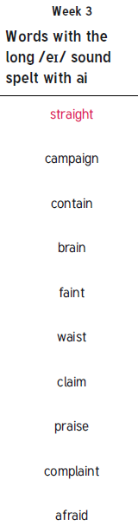information

invention

New spellings which you need to learn for next Friday 😊