Class spellings (which we have been focusing on already this week, these are just for you to remember)

temporary
trouble
ache
young
tongue
touch
treasure
vein
various
weigh

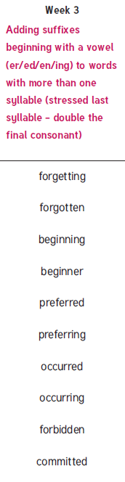
New spellings which you need to learn for next week

