Class spellings (which we have been focusing on already this week, these are just for you to remember)

plunge

subheading

submarine

subway

unkind

dishonest

untidy

unlucky

disqualify

submerge

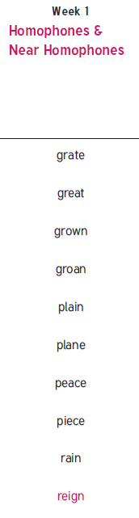

New spellings which you need to learn for next week😊