Class spellings (which we have been focusing on already this week, these are just for you to remember)

disclose

break

children

past

pass

climb

poor

great

mind

wild

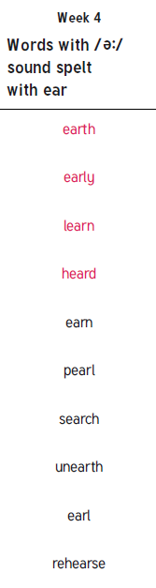 New spellings which you need to learn for next Friday 😊