Class spellings (which we have been focusing on already this week, these are just for you to remember)

couldn’t

wouldn’t

hasn’t

can’t

don’t

contemplate

confusion

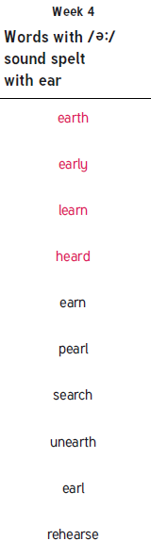there’s

weren’t

haven’t

New spellings which you need to learn for next Friday 😊