Class spellings (which we have been focusing on already this week, these are just for you to remember)

wither

aggression

boutique

calves

leaves

shelves

giraffes

chefs

antiseptic

ascend

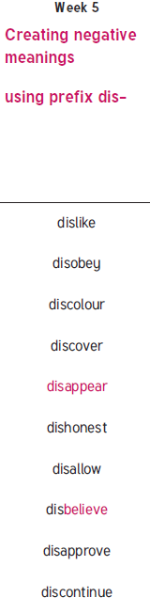New spellings which you need to learn for next week😊