Class spellings (which we have been focusing on already this week, these are just for you to remember)

imminent

tree

soil

components

rake

cycle

sow

dispersal

nectar

pollen

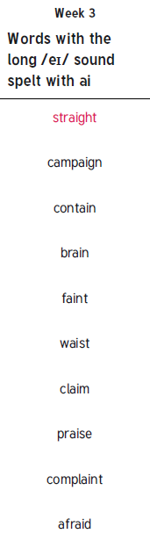New spellings which you need to learn for next week😊