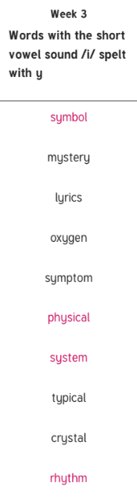

Invention

Expansion

Extension

Politician

Mathematician

Decision

Hesitation

Completion

Discussion

Action