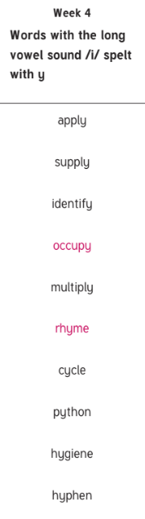

According

Variety

Accommodate

Environment

Recognise

Ancient

Familiar

Muscular

Vehicles

Guaranteed