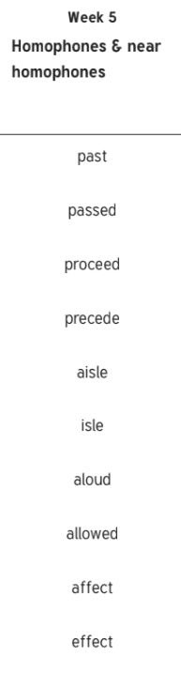

Weight

Neighbour

Rein

Weigh

Fought

Though

Thorough

Rough

Influential

non-stick